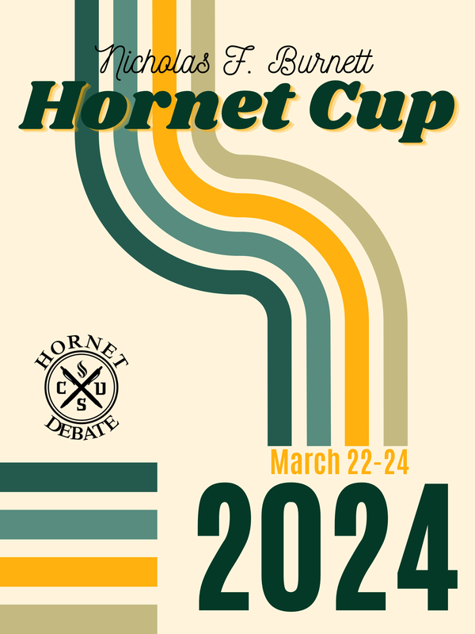
The Sacramento State Speech & Debate team
and
The Department of Communication Studies
invite you to participate in the 2024
Nicholas F. Burnett "Hornet Cup" Invitational
to be held on March 22-24, 2024.
This tournament is named to honor Professor Emeritus Dr. Nicholas F. Burnett, who was the Director of Forensics at Sacramento State from 1987 to 1996. Dr. Burnett coached Sacramento State teams to consecutive quarter-finals appearances at CEDA Nationals in 1988 and 1989 in addition to leading the team as it won many regional and national debate awards. After his nearly 10 years coaching the Sac State team, Dr. Burnett served as chair of the Communication Studies Department for five years and finally retired as the Associate Dean for the College of Arts and Letters in 2012. Dr. Burnett was a major supporter of this great activity and has touched the lives of many college debaters through the years. He had an enthusiasm for nurturing novices while at the same time coaching varsity debaters as they sought national titles. And as an administrator, he was a staunch supporter of the debate program, ensuring continued funding through the years of economic strain that hurt so many programs in the CSU. Sadly, Dr. Burnett passed away on December 1, 2021. To recognize him for his dedication and service to debaters across the nation, we host this tournament in his name.

The Hornet Cup will feature:
- NFA-LD Debate
- IPDA Debate
- All 11 NFA individual events
- The return of the limited-prep “Triathlon”
- Introducing an IPDA Round Robin
We will have a novice and open division in all Individual Events and a novice, junior, and open division offered for all forms of debate. This year we will be using Forensic Tournament (forensicstournament.net) for all entries. Please make sure that everyone on your team has a verified account and that their ballot preference is set for email.

We hope you will join us as we continue to grow this tournament!

Jared Anderson  Tournament Director/Host  Head Coach at Sacramento State mrjared@gmail.com  (530) 591-3913 (cell) | Banafshae Khan  Director of IPDA Round Robin  Assistant Coach at Sacramento State  banafshaekhan@gmail.com  (209) 475-2675
Ryan Guy –Tabroom
Director of Forensics at Modesto Junior College guyr@mjc.edu
(951) 237-8711(cell)

Tournament Information

The Hornet Cup will be ON CAMPUS this year!
Registration is at https://forensicstournament.net/HornetCup/24
You can also find more information on our website at Hornetdebate.com

Deadlines:
The deadline for entry is 5 p.m., Wednesday, March 20th. (Pacific Time)

Fees & Judging:

School Fee - $25 Debate - $30
IPDA RR - $55
IE - $10/slot
Each school is expected to provide one judge for every two debaters (LD/IPDA) entered. And one judge for every 5 (or fraction thereof) individual events entries. The uncovered debater fee will be entry fee + $70.00.
The uncovered individual event fee will be entry fee + $30.00.

Awards:

We will have awards for all participants in elimination rounds. In debate, we will also recognize the top 5 speakers in each division.

Sweepstakes
The Hornet Cup is a sweepstakes award recognizing the top team based on the results of the top 3 participants from each team (.5 points for each debate prelim win, 1 point for first elim win, 2 points for subsequent elim wins. IE’s will count 2 points for 1st, 1 point for 2nd, .5 point for 3rd, and .25 points final round participants outside of the top 3) Sacramento State debaters will compete but will NOT be eligible for sweepstakes awards.

Hotel & Travel Information:

We will not have a reserved block, but the following hotels are nearby and should offer a reasonable rate. You can find lots of hotels with various rates and distances from campus, however, not all of them are hotels you may be comfortable bringing your team to (please check reviews!) The hotels listed below are all places we would be comfortable in.

Hampton Inn & Suites Sacramento @ CSUS (closest to campus): (916)451-1135

​Home2 Suites by Hilton Sacramento @CSUS (same location): (916)451-1459

Fairfield Inn Sacramento Cal Expo (about 2 miles from campus): (916)920-5300

TownePlace Suites Sacramento Cal Expo (about 2 miles from campus): (916)920-5400

The Sacramento Airport is about a 20 minute drive from campus and the Hampton Inn. There are plenty of rental car companies in the airport. To get to campus or the hotel from the airport, take I-5 south, then merge onto highway 50 east towards South Lake Tahoe. Exit at Howe/Power Inn Road and follow the signs to campus.
​Sac State’s address is 6000 J Street, 95819. However, you may also have success with your GPS/Navigation by entering specific building names. Please note that Sacramento has been doing a LOT of road construction, especially on Highway 50. This may impact your travel time.

Internet:
While on campus, connect your devices to our official wireless network, eduroam. To keep campus securely connected, we support over 1,600+ Wi-Fi access points, offer guest and event access, continue to upgrade buildings and structures to Wi-Fi 6 speed, as well as expanding Wi-Fi coverage to meet the growing needs of our campus community.

Parking:
Students and community visitors to Sacramento may use this convenient payment service to purchase daily parking from their smartphones — no need to visit a physical permit machine.
This service is only valid for student spaces. We recommend Parking Structure 2!

You may also download the free PaybyPhone app from your smartphone app store.
The PayByPhone parking permit is linked to the vehicle’s license plate number (or VIN) that you specify. When the vehicle’s license plate number is checked by the parking officer, it will show the PayByPhone permit purchase.

- Be sure to include the location code: 5115
- New cars with no license plate number can enter the last 7 digits of the vehicle identification number (or VIN).

Sac State Mobile App
- Download Sac State Mobile App
- Tap "Commute"
- Tap "Pay By Phone"
- Tap "Register"
- Follow on-screen instructions to register your phone number and enter credit card information
- Tap "Start New Parking"
- Enter your license plate (use last seven digits of VIN if no license plate is available)
- Use the Sac State location code: 5115
- Choose daily or two-hour parking

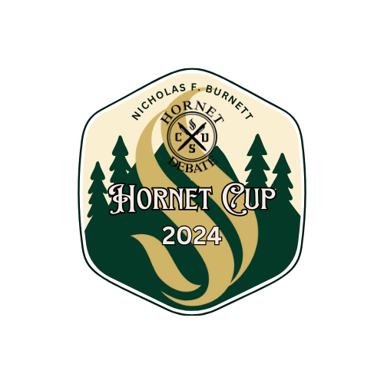

Tournament Procedures

NFA LD

We will use the current NFA-LD topic and adhere to NFA rules.

Rules can be found here - https://nationalforensicassociation.org/competition/#debate

“Resolved: The United States federal government should substantially reduce the number and/or role of its nuclear weapons.”

Divisions/Eligibility: We will offer Open, JV, and Novice divisions for LD debate.

Open – Available all eligible students, regardless of experience

JV – Available to students in their first four semesters of collegiate debate (of any kind)

Novice - Available to students with less than two semesters of any debate at any level (high school or college).

Divisions may collapse if necessary. We will make every effort to preserve a novice division. This may mean that we don't break brackets and students from the same team may debate each other. There will be no breaking of brackets in elimination rounds.

Schedule/Feedback: We are offering 6 preliminary rounds and appropriate elims so that all winning records will break to a final bracket. We will, if necessary, have partial-elimination rounds in order to break all winning records.

Judges are highly encouraged to DISCLOSE their decisions and offer feedback after the round. Please remain conscientious of the schedule. We also may alter the schedule, including changing the number of rounds, if required. In the past we have had to cancel round 6 due to the mathematical impossibility of pairing the round. With a sufficient number of schools and entries, this should not be necessary.

We will utilize the RKS Decimal scale for speaker points; points are awarded in one- tenth increments and no ties are allowed.

Tie breakers - All winning records will break, power-matching and seeding will be determined first by W/L record and then by opponent wins, starting at the break line.

IPDA Round Robin

The 2024 Hornet Cup will feature our first ever “Round Robin”. Six students will be selected to participate in a five round “round robin” tournament. Each round will have two judges – one judge needs to be supplied by your team to cover your entry and one judge will be provided by the tournament from the Sacramento community. The round robin runs concurrently with, and use the same topics as, the general IPDA tournament so that you can still prep your debaters as a team. Rounds 4 & 5 of the round robin will coincide with the bronze and silver/gold rounds and the winner of the round robin will be determined by overall ballot count.

IPDA Debate – General Tournament

We will adhere to the norms and structures of IPDA for speech times, prep, topic strike, and other structural norms. However, please note that this is NOT an IPDA sanctioned tournament so there may be some differences.

For the 2024 Hornet Cup topics will be in the general area of “The Social Safety Net”
- Students will be provided 5 topics at the beginning of the round.
- Students will rotate striking one topic from the list, beginning with the opposition speaker.
- IPDA prep will begin 30 minutes before the debate begins.
- All winning records will break to festival elims (bronze round, gold/silver round).
- We will use speaker points for seeding/tie breaks

Bids for the IPDA Round Robin

We would like to invite you to submit bids for entry to our first annual Round Robin. We are looking for excellent students to take part in this competition and will be accepting bids for ONE student per school. Applications will be evaluated and ranked by a small committee (not the current coaching staff for Sac State) and the six students receiving bids will be notified and announced on March 8th.

Please submit applications to - https://forms.gle/uQo79nEUHjqGTQ7w6
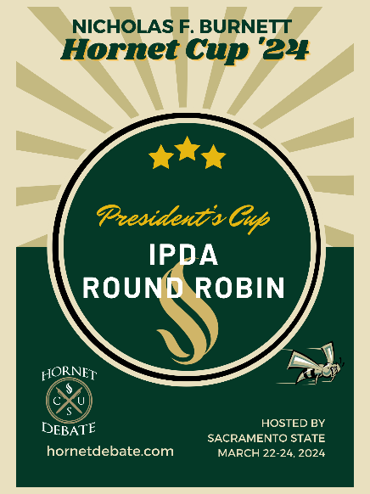

Individual Events

We are offering all 11 NFA individual events. Please see NFA bylaws for event descriptions.

Collapsing Divisions: Every effort will be made to protect novice competitors; however, if there are fewer than 8 entries in a division, that event may be collapsed. If this occurs, top non-advancing novices will be recognized at the awards ceremony.
Additionally, in order to best utilize judges, when the total of all divisions of an event is 12 or fewer contestants, with no division having 6 or more contestants, the divisions could be mixed in the same room with the same judge, and the contestants ranked separately.

Forfeiture Rule: Competitors not fulfilling their obligation to comply with the tournament schedule will be subject to forfeiture. Individual events competitors, regardless of double entries, must arrive at their rounds within 45 minutes of a round’s scheduled start time or risk forfeiture.

Criteria for Elimination Rounds: Any event with less than seven entries will not have a final round. Events with thirty-four entries should have semi-final round, or an additional judge assigned, if possible.

Advancement to Elimination Rounds: No more than half of the field will be advanced to finals. Students will be rank-ordered first by lowest cumulative rankings, finally by the highest reciprocal score (a.k.a. decimal conversion), and finally by the highest cumulative ratings.

Placement/Advancement in Elimination Rounds: Students will be rank-ordered by lowest cumulative rankings, then by judge’s preference, then by the highest cumulative ratings, and finally by the highest reciprocal score (a.k.a. decimal conversion).
Pattern A: POI, Drama, Info, Impromptu, Duo, CA
Pattern B: ADS, Poetry, Prose, Persuasion, Extemp

Limited-Prep Triathlon:
Students competing in triathlon should be entered in Impromptu, Extemp, and Declamation. The triathlon winner is determined by the cumulative scores across all three events, there will be no “final round”. Students will compete in both Impromptu and Extemp with the rest of the field, regardless of whether they are also entered in triathlon, however, only students who are entered in triathlon may enter Declamation. There will be two rounds each of Impromptu and Extemp, with one round of Declamation. The lowest cumulative score will win the triathlon (final round scores for Ext/Imp will not be counted).

Limited Prep Declamation:

In the eighteenth century, a classical revival of the art of public speaking, often referred to as The Elocution Movement was underway. While elocution focused on the voice— articulation, diction, and pronunciation—declamation focused on delivery of the speech. For this event, we have modified the idea of declamation as a limited preparation event. Similar to the model of an extemp round, speakers will enter a common prep room to await their prompt. When their speaker number is drawn, the student will be given three speech transcripts to choose from. These transcripts will be available in a speechdrop.net room and the student will be given the code at draw time. Students will also have access to one printed copy of their transcript if they want it (please request this ahead of time).The students will then have 30 minutes to select their speech, cut/edit, and practice the speech. Before the end of their 30 minute prep time, the student should go to their competition room and deliver a five minute speech (walking time is part of prep time). This five minute cutting should adhere to the original manuscript much in the way an interp cutting would. The student does not need to, nor should they, rewrite or paraphrase the speech.

Judges should evaluate the declamation speech based on delivery and effectiveness of the cutting.

Tournament Schedule (All times are Pacific)

Friday | Saturday
9:00 am: Registration | 8:00 am: Registration & Pairings released
10:00 am: IPDA Round 1 (RR1) | 8:30 AM: IPDA Gold/Silver Round (RR5)
11:30 am: IPDA Round 2 (RR2) | 9:30 AM: Pattern A Round 1 – POI, DI, Info, Imp, Duo, CA
LUNCH (on your own) | 11:00 AM: LD - Round 1
2:00 pm: IPDA Round 3 (RR3) | 12:00 PM: Lunch
3:30 pm: IPDA Bronze Round (RR4) | 1:00 PM: Declamation Draw
 | 1:30 PM: Pattern A Round 2 - POI, DI, Info, Imp, Duo, CA, Declamation
 | 2:30 PM: LD - Round 2
 | 3:30 PM: Pattern A Finals – POI, DI, Info, Imp, Duo, CA
 | 4:30 PM: LD – Round 3
 | 5:45 PM: LD – Round 4

Sunday
8:00am: Extemp Draw (round 1)
8:30 AM: Pattern B Round 1 – ADS, Poetry, Prose, Pers, Extemp
9:45AM: LD – Round 5
11:00 AM: Extemp Draw (round 2)
11:15 AM: Pattern B Round 2 – ADS, Poetry, Prose, Pers, Extemp
12:30 PM: Lunch
1:30 PM: LD Round 6
2:45 PM: Extemp Draw (finals)
3:00 PM: Pattern B Finals – ADS, Poetry, Prose, Pers, Extemp LD ELIM 1
4:30 PM: LD ELIM 2
AWARDS ASAP

This schedule should allow students to cross enter in any events they choose. We would like to encourage you to try events you may not have tried before.

